**Capstone Project- Back End / Read.me**

Overview This is my capstone project assignment that was given by General Assembly. Our assignment included creating a website of our choice. I based it on one to many relationships. I created a Single Page Application for the web that would allow a user to to interact with the website and the back end was used to authenticate the functions of CRUD.

**Link to Front End**

* Deployed App : <https://kimbermenjivar.github.io/SouthernBelleCulture-Client/>
* Repository : <https://github.com/kimbermenjivar/SouthernBelleCulture-Client>

**Links to Back End**

* Deployed Back End :  <https://github.com/kimbermenjivar/SouthernBelleCulture-BackEnd>
* Repository :  <https://southernbelle.herokuapp.com/>

**ERD,User stories, Wireframe**

Users:

Can have many Quotes

Quotes:

See southern Quotes

Add Southern Quotes

User Stories for Southern Belle Culture:

* Users can sign up
* Users can sign in
* Users can change password
* Users can sign out
* Users can See Southern quotes
* Users can add Southern quotes
* Users can update a quote
* Users can delete a quote

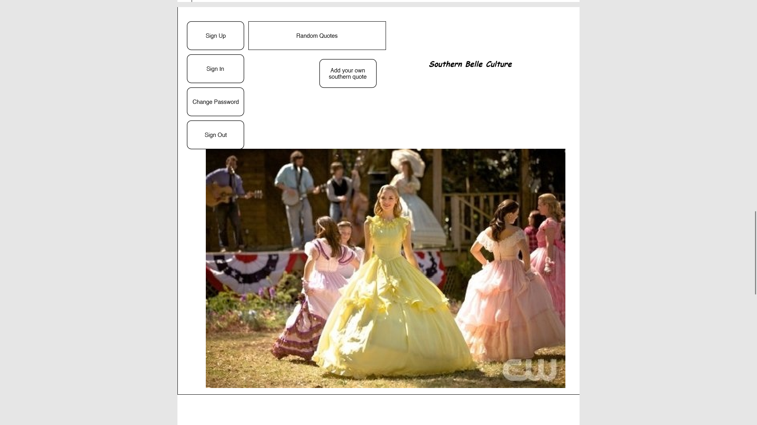

**Project Requirements are:**

My app has been deployed on Github and Heroku. Many cohesive commits dating back to the first day of building my project. This read.me was created to document the process and technologies used:

* RUBY
* AJAX
* Jquery

**Stretch Goals**

I wanted to change the fonts and maybe change the quotes to pop using modals and handlebars

**Routes, CRUD actions**

Authorized routes

* GET : router.get('/southerncultures') - https://southernbelle-herokuapp.com/southerncultures
* GET by ID: router.get('/southerncultures/:id' ) - <https://boiling-harbor-16682.herokuapp.com/bl-items/:id>
* DELETE : router.delete('/southerncultures/:id') - https://southernbelle-herokuapp.com/southerncultures/:id
* UPDATE : router.patch('/southerncultures/:id') - https://southernbelle-herokuapp.com/southerncultures/:id
* CREATE router.post('/southerncultures/:id') - https://southernbelle-herokuapp.com/southerncultures

**How things went:**

I started with what was needed to meet to MVP project requirements. I created an ERD and wireframe.

I worked on design using bootstrap, html, CSS and SASS. I used HTML to Sign up with email, password and password confirmation HTML to code and backend api. I added HTML code for log out while logged in. I worked on Read.me, User stories as well tested the crud code with a few updates to fit my project needs such as not allowing delete or updating unless its the user. Added html code for changing password with current and new password I tested everything seems to be working fine.